ASCE Pittsburgh and friends held the Clean Water Festival on October 15, 2022 in Millvale Riverfront Park. Overall, the day was a resounding success. A very special thanks to all those that supported and attended the festival including our invited speakers, exhibitors, artists, volunteers, and sponsors.

Our goals in hosting the Clean Water Festival were to:
- Celebrate the 50th anniversary of the Clean Water Act and educate the general public on its historic importance,
- Raise awareness of existing water pollution challenges that still remain,
- Bring together clean water advocacy groups and organizations from around the Pittsburgh region, and
- Create an inclusive and welcoming water themed public festival for all ages with fun water themed activities, exhibitors, and artists.

Prior to festival day there were various lead-up events which helped build excitement around the topic of clean water in Pittsburgh. We held stream cleanups with water advocacy organizations including; Allegheny CleanWays, Friends of the Riverfront, Watersheds of South Pittsburgh, and Upstream Pittsburgh. We partnered with Row House Cinema in Lawrenceville for a water themed movie night.

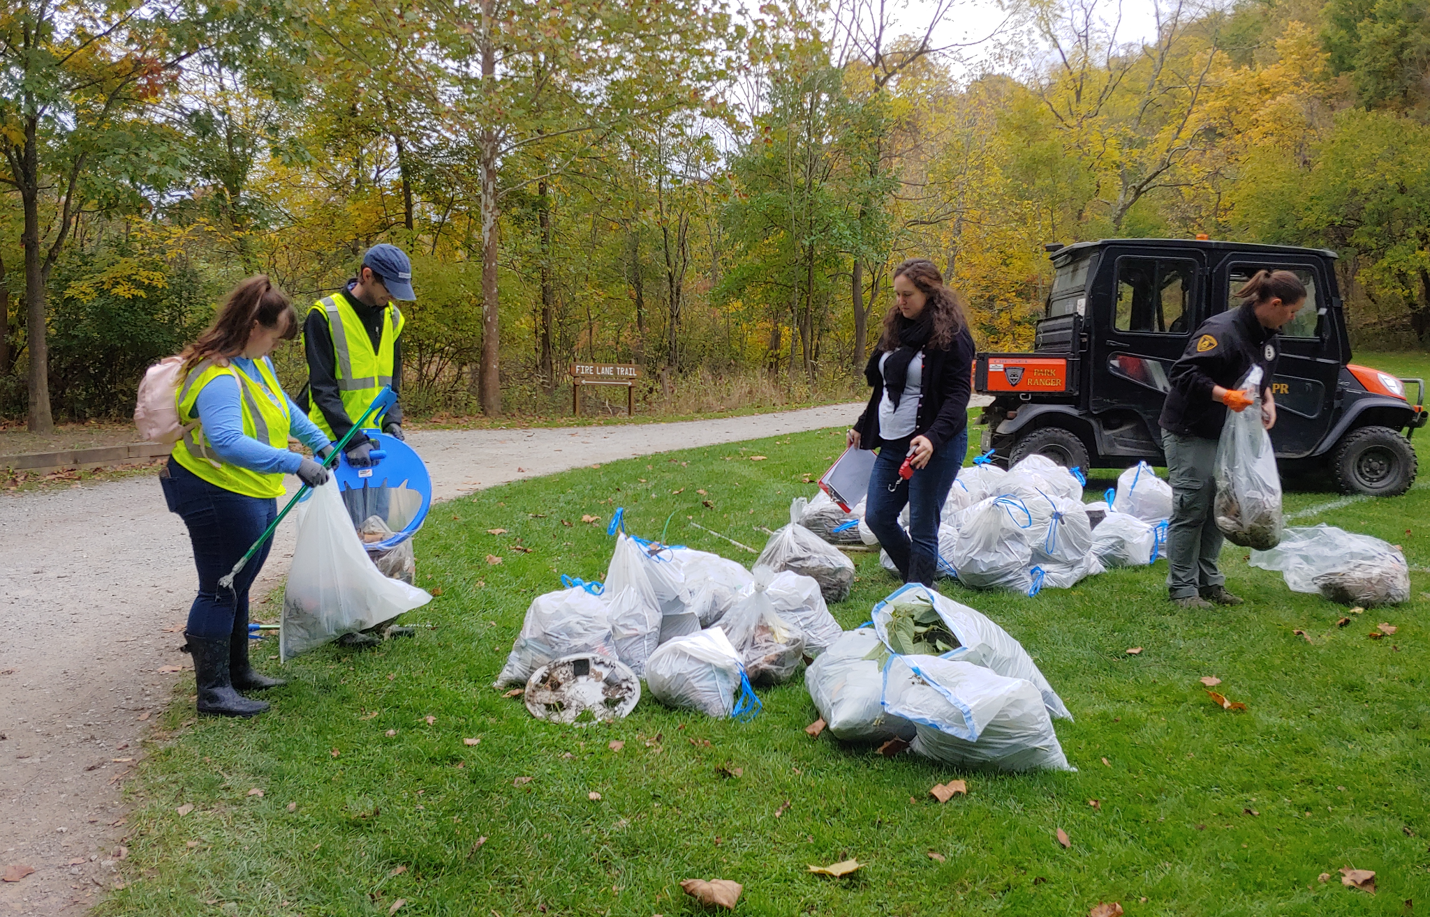

It was a perfect October fall day with temperatures in the upper 60s, sunshine and blue skies. In total, we estimate we had 600-700 people in attendance. We had over 40 organizations involved and numerous financial sponsors. Both WXPI and KDKA (link to KDKA coverage) came and provided media coverage, interviewed the festival planning committee, and ran short pieces later that evening. ASCE also had two op-ed’s published on the importance of the Clean Water Act and the festival; One in the Tribune Review (link to article) and another in the Pittsburgh Post Gazette (link to article).

Below is a brief festival recap summarizing some of highlights from the day:
- Dr. Emily Elliott from the University of Pittsburgh and director of the Pittsburgh Water Collaboratory kicked off the festival with a moving keynote speech on the history of clean water in Pittsburgh and the United States. The progress we have made in cleaning up our rivers from when they were once used as open sewers. She also reflected on the challenges that still remain including solving stormwater, sewage overflows, industry, and legacy pollution.
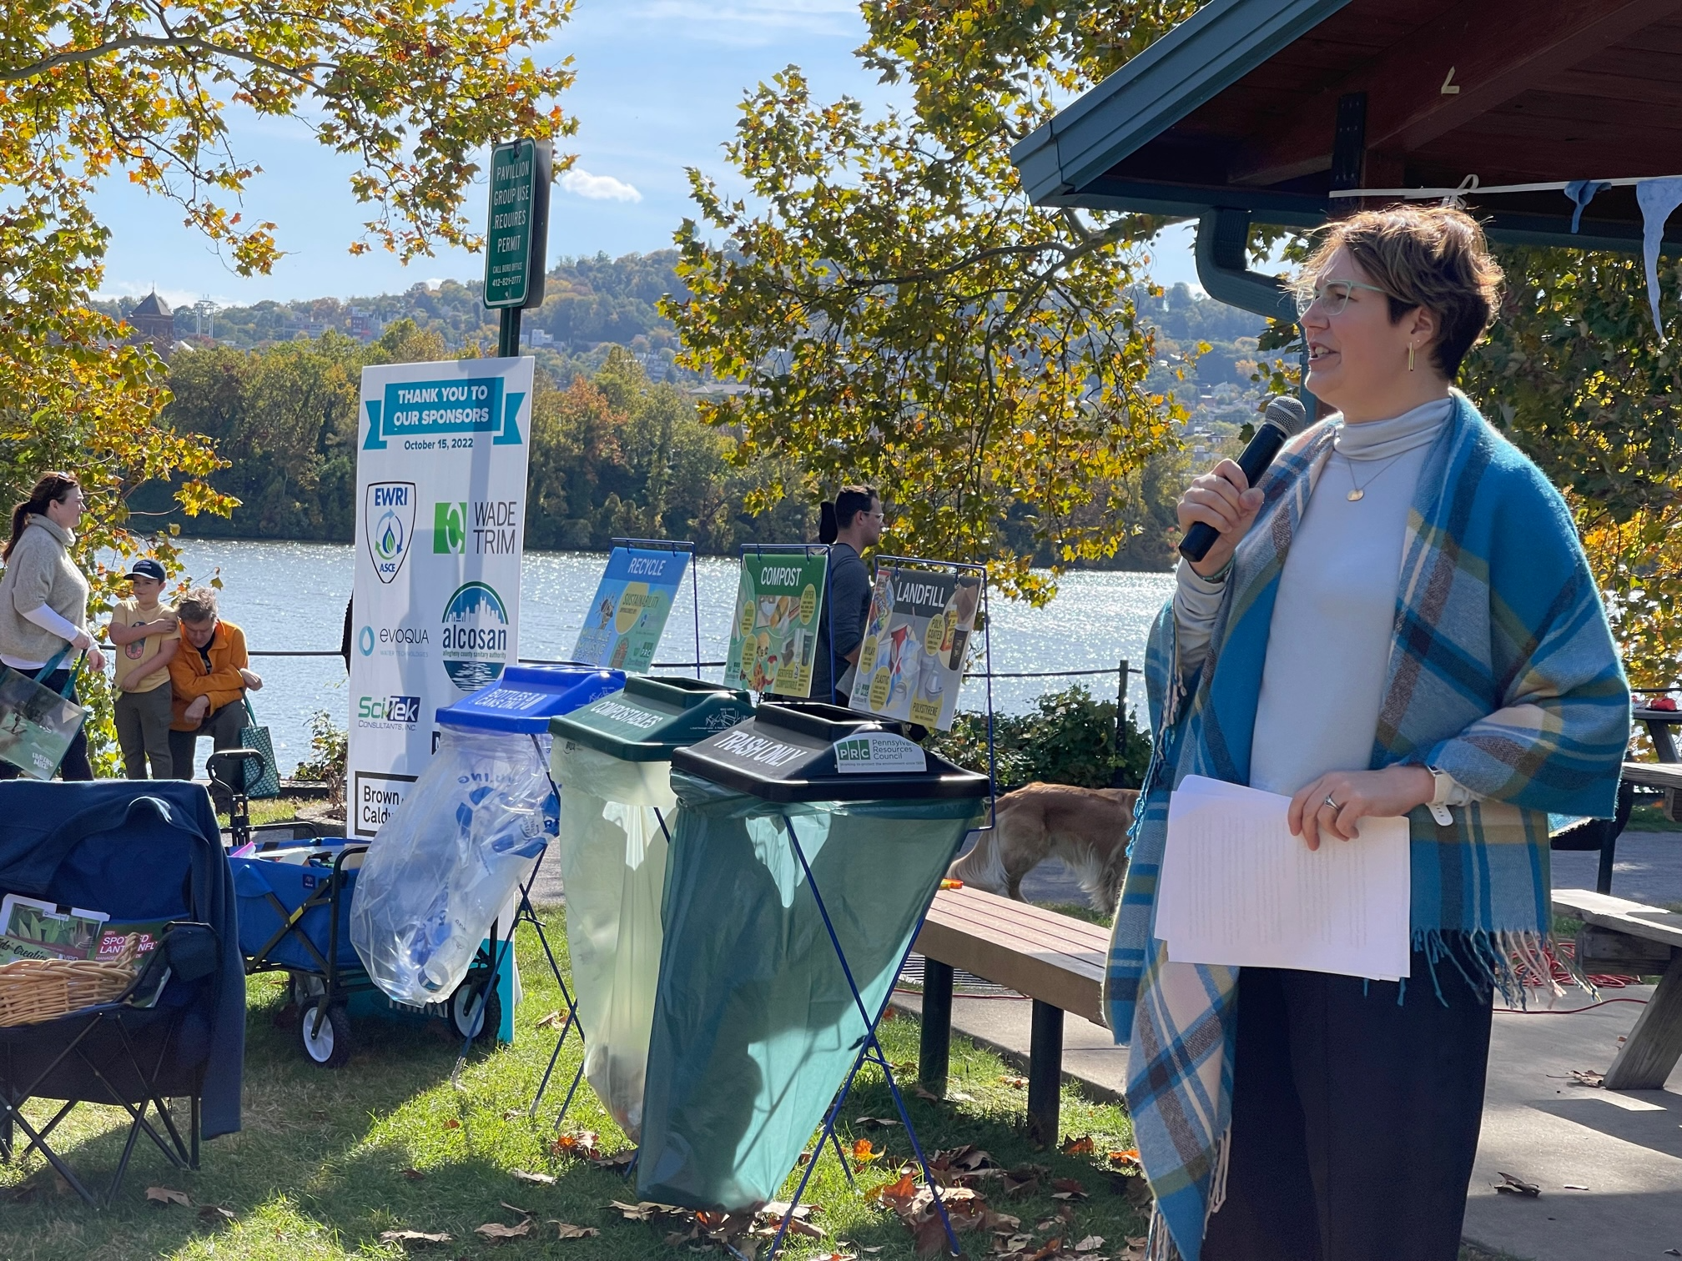
- We also had two excellent and conversational panel discussions in the Three Rivers Rowing Association boathouse meeting room. The first panel focused on the importance of community involvement in creating a healthy environment and clean water. The focus of the second panel was on pollutants in our waterways.
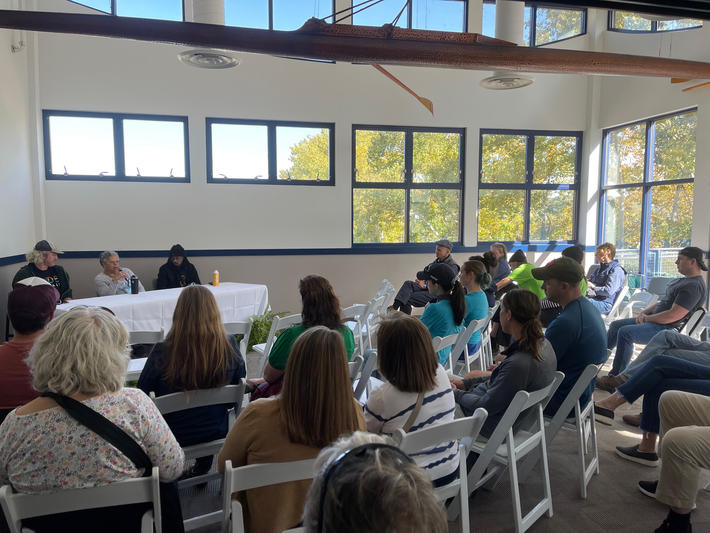
Also a big thank you to Three Rivers Rowing Association for loaning their fantastic upstairs meeting venue and being a valuable contributor on the festival planning committee. Also thank you to Upstream Pittsburgh for organizing and leading the community panel discussion. Upstream Pittsburgh provided support from the very beginning on the festival planning committee.
- Tree Pittsburgh set up shop and gave away almost a 100 free trees. We were pleased to see that by 2pm, just about all the trees were taken and will soon be soaking up stormwater in a watershed somewhere around Pittsburgh.
- The Three Rivers Heritage Council provided an inspiring dance and drum performance. The performers spoke about the spiritual connection between people and water and how Pittsburgh is blessed with an abundance of water but must care for it and not take it for granted. Water is essential to life and we must cherish it for all people and generations to come.
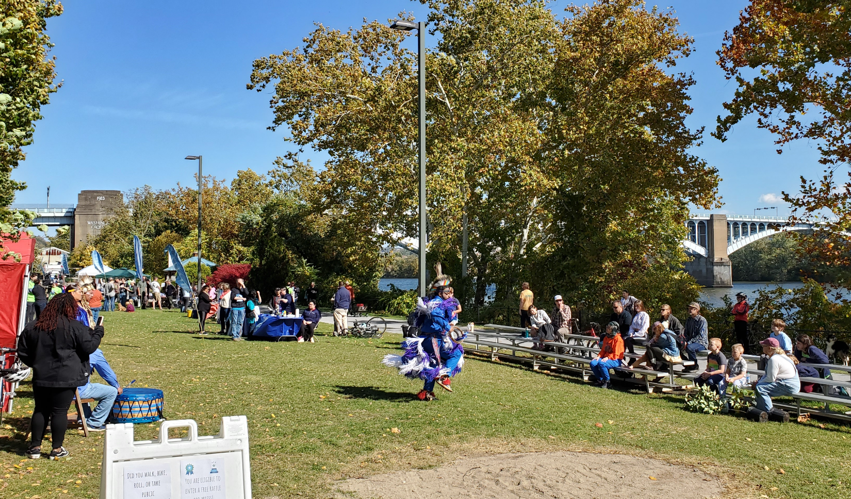
- A very special thanks to Myrna Newman at Allegheny CleanWays for organizing the festival artists. As well as be Galleries in Lawrenceville for providing financial support to the festival artists. A festival would not truly be a festival with decorative flair and artistry. We had several hands on art activities on the grounds for kids to enjoy.
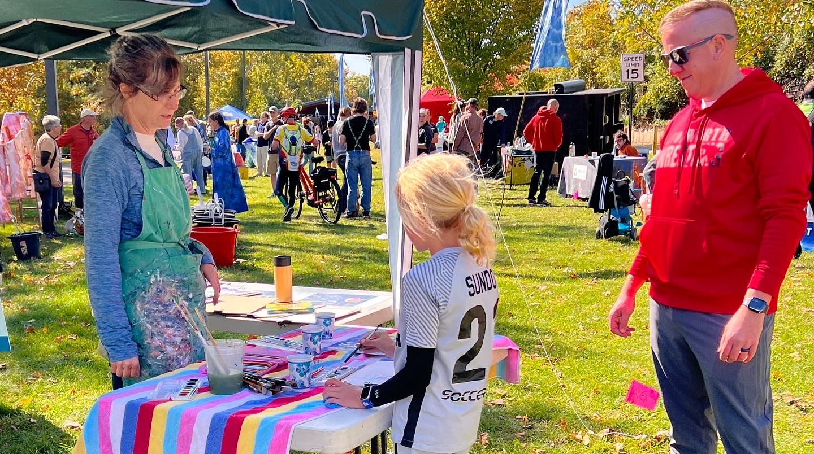
- Bob Hedin of Hedin Environmental and his make your own tie-dye shirt was a major hit. His tie-dye station used reclaimed acid mine water and provided a neat way to educate the public on the issues of legacy acid mine drainage in Pittsburgh. ASCE Pittsburgh gave away over 300 free commemorative t-shirts that were used at Bob’s station.
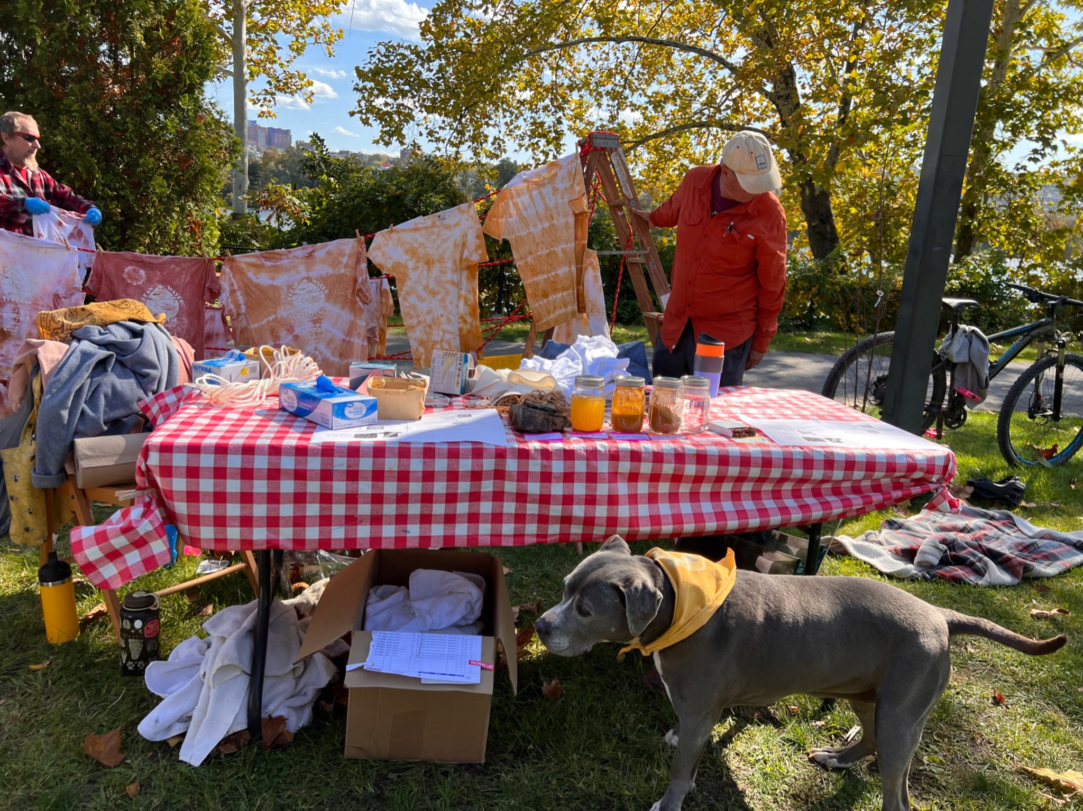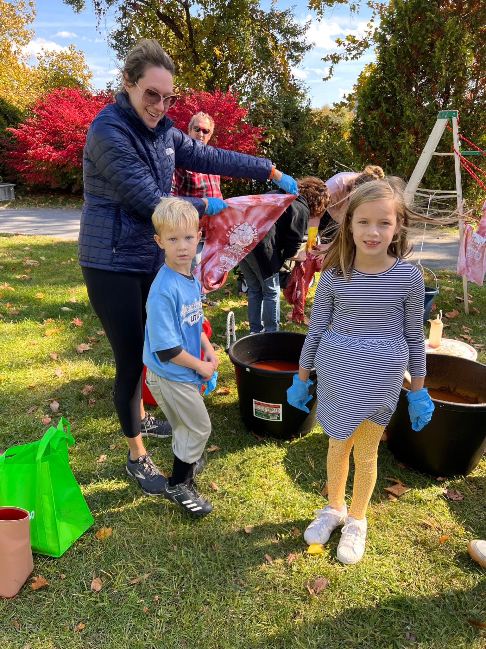
- Support from local water government agencies was crucial to the success of the festival. Both The Pittsburgh Water and Sewer Authority and the Allegheny County Sanitary Authority were major supporters of the festival, including offering volunteers and pro-bono contributions on the festival planning committee. Without their involvement this event would not have been as impactful as both are the preeminent Pittsburgh government leaders in clean water. The panel discussion at the end of the festival with Jennifer Kennedy (ALCOSAN Director of Engineering), Will Pickering (CEO of PWSA) and James Miller (PA Department of Environmental Protection) was an important discussion. We reflected the progress we have made but realize we still have a way to go in ensuring clean water. It is recognized that we will need significant investment in water infrastructure in the coming decades including ALCOSAN’s Clean Water Plan and PWSA’s Strategic Plan for Stormwater and Wet Weather Plan. Educating the public on these challenges will need to be continued and an on-going process.
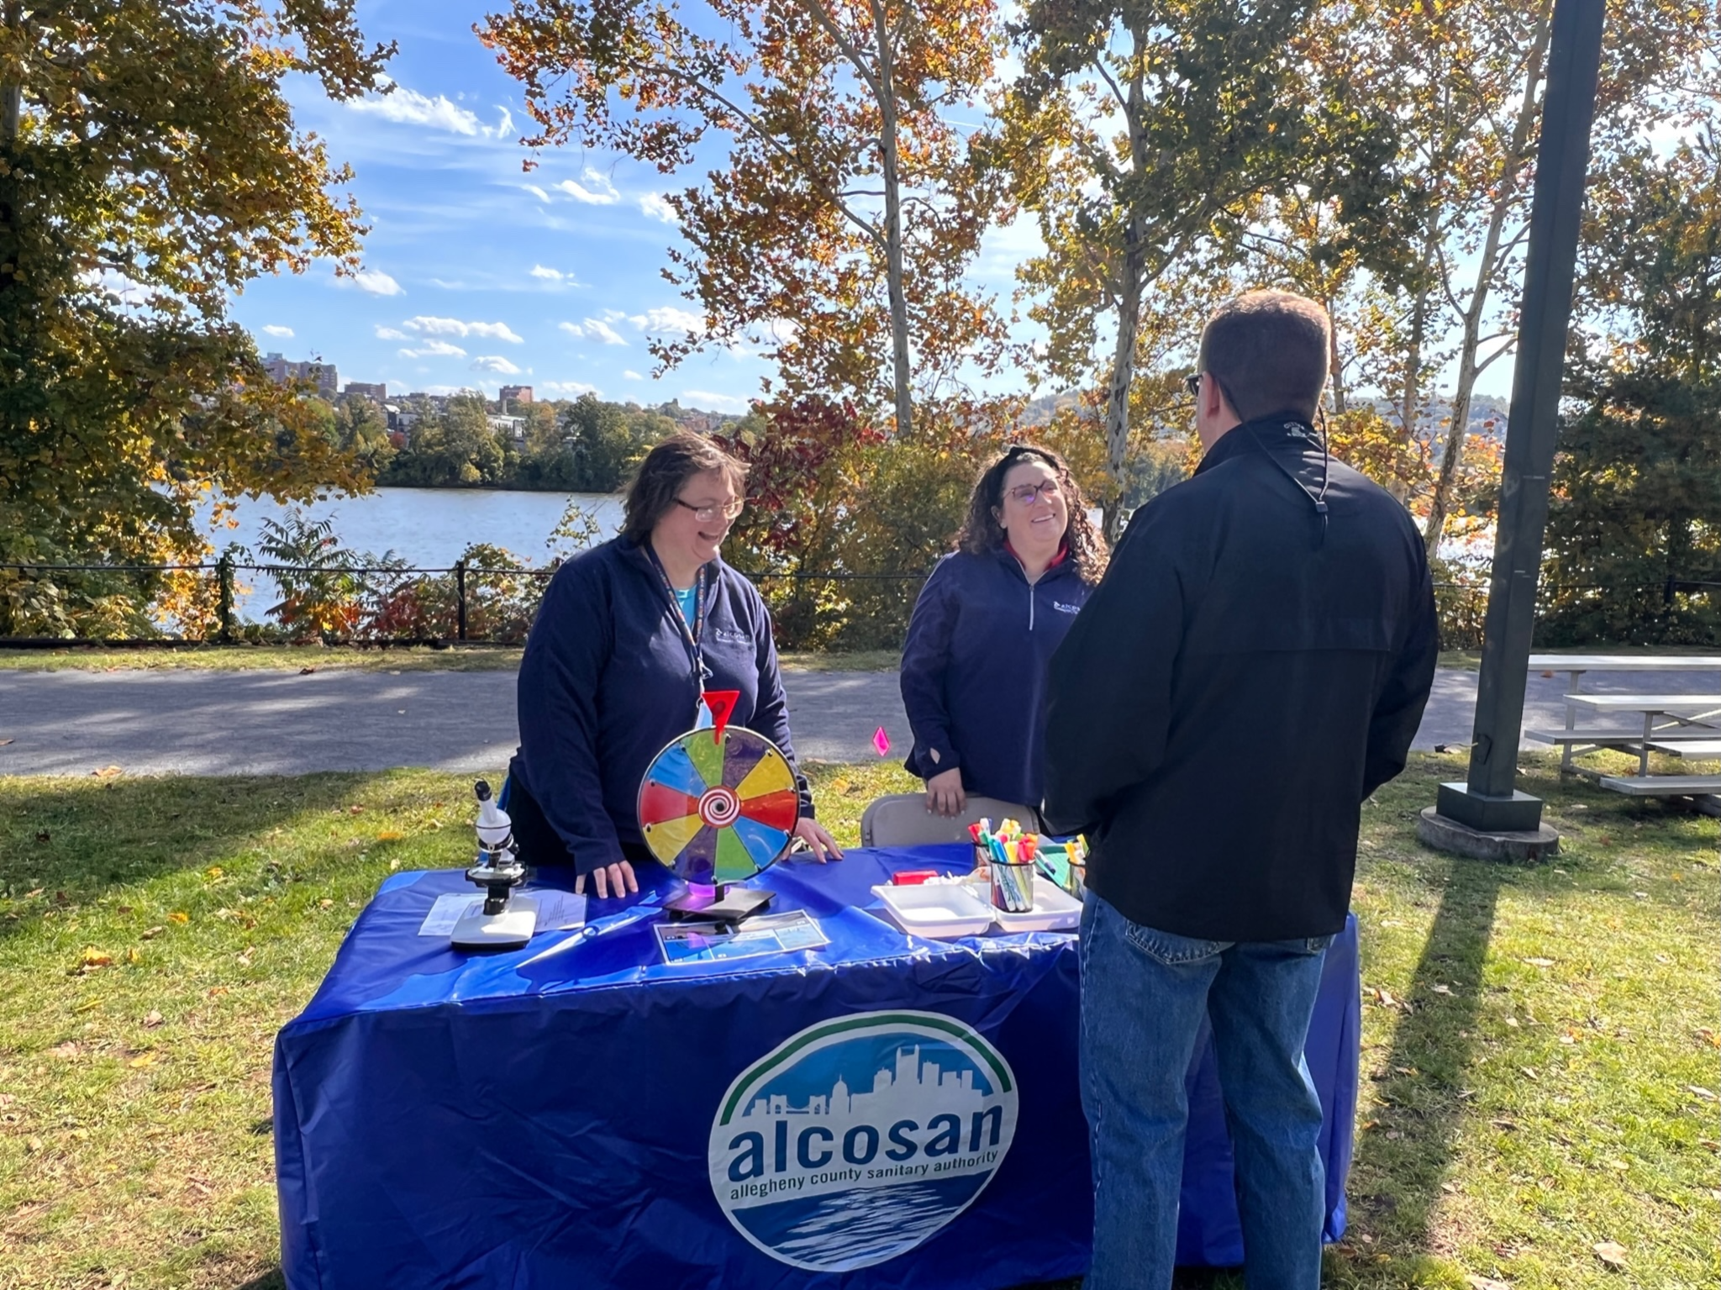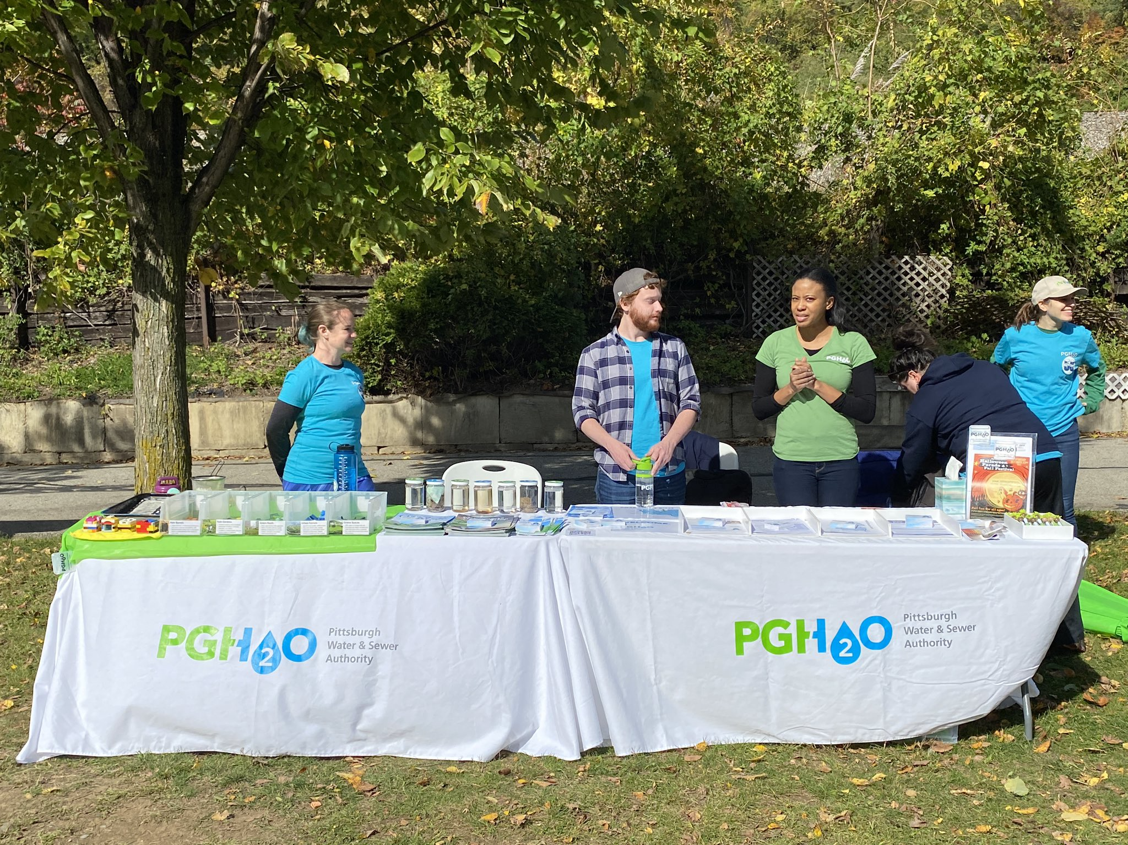
- To close out the festival Friends of the Riverfront had their bike parade from the festival grounds to the Point to raise clean water awareness and the importance of Pittsburgh’s valuable riverfront trail system. The Carnegie Science Center exhibitor tent also had a fun fish print to attach to the bikes. A very special thank you to Friends of the Riverfront and Kelsey Ripper for their involvement from the beginning in organizing the festival and the bike parade.

Overall, the positive response and attendance from the general public and our exhibitors was overwhelming. Perhaps the most important takeaway from the festival is the level of participation from so many groups and organizations. Many volunteered their time free of charge for making the festival possible. It demonstrates that Pittsburgh has a strong and tight knit water community and we all have a hand in ensuring the future of clean water in Pittsburgh.
Lastly a huge round of virtual applause to our festival planning committee. The festival planning committee met on a regular basis for several months tackling all the nitty gritty logistics that made the festival possible. Putting on a public festival of this magnitude takes a massive effort behind the scenes. The planning committee did it all including budgeting, corporate fundraising, program development, brand marketing, website development, media promotion, creating site maps, recruiting festival artists and food trucks, and hour by hour festival execution logistics. Hats off to the whole group!

Festival Planning Committee Members:

Jeff Argyros, ALCOSAN
Jason Baguet, Sci-Tek
Tom Batroney, HDR
Ana Bennett, The Pittsburgh Water and Sewer Authority
Aaron Birdy, UpstreamPgh
Ben Briston, Gannett Fleming
Coreen Casadei, Collective Efforts
Shirley Clark, Penn State Harrisburg
Darnetta Craig, Colliers Engineering & Design
Malu Devadasan, Wade Trim
David Dzombak, Carnegie Mellon University
Jess Friss, Three Rivers Waterkeeper
Jake Gibas, AECOM
Ben Grunauer, The Pittsburgh Water and Sewer Authority
Alen Gusa, Sci-Tek
Hali Hetz, The Pittsburgh Water and Sewer Authority
Justin Kerns, msconsultants
Tia Kirby, Wade Trim
Myrna Newman, Allegheny Cleanways
Kelsey Ripper, Friends of the Riverfront
Danielle Rhea, Penn State Extension
Julia Saintz, Evoqua Water Technologies
Cesar Simon, Cosmos Technologies
Shirley Tang, AES
Mary Wilson, Penn State Extension
Heather Hulton VanTassel, Three Rivers Waterkeeper

