PRESIDENT'S MESSAGE
June 2023

Members,
I don’t claim to know much about the facts of life, I can barely even remember what I had for breakfast this morning, but one recurring theme I’ve come to realize in my short time on this planet is that more often than not the level of joy and fulfillment I get out of something is directly proportional to the level of sacrifice put in. As Theodore Roosevelt once said, “Nothing worth having comes easy.” We all know this, but I find that I often need to remind myself regularly of this seemingly universal truth.
When I became Section President I knew a lot of my free time in the evenings and weekends would be gone out the window. But I also knew that the sacrifice of my free time would be worth it in the end. This past year has been one of the more time consuming years of my career but at the same time it has been one of the most gratifying and fulfilling.
It is bitter-sweet that my term as President has come to an end. It was a great honor. Especially looking back at all the Section accomplished over the past year. What a great team effort from a group of individuals who all collectively believe in the mission of the Society. Individuals that believe in volunteering their precious free time will pay off in the long run both personally and professionally. I really couldn’t be more proud to be a part of this 100% volunteer led organization and feel lucky to have had such great support during my presidency.
Here’s a recap of the Section’s accomplishments over the past year. Virtual hats off to those that made these happen, you know who you are!
- We celebrated the 50th Anniversary of the Clean Water Act. We published two op-eds, one in the Post Gazette and another in the Tribune Review. As part of the celebration we co-hosted volunteer stream cleanups. We then partnered with numerous government agencies and Pittsburgh nonprofit organizations to host a water themed public festival in Millvale Riverfront Park with over 600 people in attendance. Click here for a recap article of the festival.
- We participated in the release of the 2022 Pennsylvania Infrastructure Report Card. As part of the release we held a press conference that received extensive news coverage. See news reports from local TV affiliateshere,here, andhere.
- Hosted our annual Life Members Banquet at the LaMont where we honored ten new ASCE life members from the Pittsburgh Section. Laura Zurowski presented a fascinating and entertaining lecture to nearly 100 in attendance on the infrastructure history of Pittsburgh’s steps.
- Hosted our e-Week Annual Awards Dinner to a sold out room at the Western Pennsylvania Engineer’s Society where we honored the best civil engineering projects of the year and recognized exemplary individuals in the profession.
- We attended legislative day Washington DC fly-in where the Pittsburgh Section accepted the national Outstanding Civil Engineering Advocate Team Award for our response in the local and national media to the Fern Hollow Bridge collapse. Read all about the fly-in in a two part article series here: Part 1 and Part 2.
- The Young Members Forum held a fantastic Winter Banquet to a sold out room at the Pittsburgh Aviary. See recap of the event linked here. The Young Members Forum also met throughout the year hosting various young member oriented social events and happy hours.
- YMF and Section board members attended the ASCE National Convention in Anaheim, CA where YMF board member Jayne Marks received the national Collingwood Prize for best paper. We also attended the ASCE Multi-Regional Leadership Conference in Charlotte, NC where we learned some valuable best practices to improve the Pittsburgh Section going forward.
- We continued our K through 12 Educational Outreach initiatives to inspire our next generation of civil engineers at Future Cities Competition and Science Fairs.
- We continued our efforts with engaging and supporting Engineers Without Borders.
- We improved our internal operations:

  - We updated the Section by-laws.
  - Instituted a new Deputy Treasurer role to help better delegate and streamline treasurer duties.
  - Instituted a new Faculty Practitioner Advisor Champion board role to improve communications between the Section and our ASCE University Student chapters.
  - While we remain financially strong, we continue to look to sustain and grow new membership numbers. Our focus going forward is retaining early career professional membership numbers and reaching out to seasoned professionals who have lapsed memberships to bring them back into the fold.
- We held numerous technical lectures, workshops, seminars and tours:

  - Geo-Institute

    - 9/15/2022 - Cross-USA Lecture “Geotechnical Challenges for the Future of Transportation”
    - 10/25/2022 - October Lecture “Geotechnical Aspects of the I-579 Cap Urban Connector Project”
    - 11/12/2022 - Fall Short Course “Quantitative Risk Assessment in Geotechnical Engineering”
    - 1/19/2023 - Joint DInner Lecture "Montgomery Locks and Dam Subsurface Investigation" event recap article found here.
    - 2/23/2023 - February Lecture "3D Slope Stability Analyses in Practice '' event recap article found here.
    - 3/23/2023 - DFI Traveling Lecture "The Art & Science of Hole Digging"
    - 4/19/2023 - Annual Student Night Poster Competition
    - Upcoming Event: Members Appreciation Picnic and Park Cleanup in North Park
  - Structural Engineering Institute

    - 8/25/2022 - Site Tour: “Charleroi Lock and Dam” event recap article found here.
    - 11/10/2022 - T.R. Higgins Lecture: “Dr. Amit Kanvinde: Column Base Connections: Research, Design, and a Look to the Future”
    - 3/16/2023 - SEI/ABCD Joint Dinner - “CSVT Bridge: Design and Construction Challenges”
    - 4/28/2023 - Site Tour: “Pittsburgh International Airport Terminal Modernization Program (TMP) Project”
  - Utility Engineering and Surveying Institute and Transportation and Development Institute

    - 9/22/2023 - Virtual Event: “Asset Management Seminar: The Opportunity to Think Differently About Infrastructure”
  - Utility Engineering and Surveying Institute

    - 5/15 to 5/19/2023 - Workshop: 5-day Utility Investigation School
  - Environmental and Water Resources Institute

    - 3/30/2023 - Conference: Co-Hosted with Pennsylvania Water Environment Association - “Pennsylvania Stormwater Summit”
    - 4/20/2023 - Tech Talk: “Can Smarter Watersheds Accurately Monitor Emerging Contaminants?”
In addition to our past accomplishments, we have numerous forthcoming initiatives:
- A focus on justice, equity, diversity, and inclusion. ASCE Pittsburgh will be hosting a free webinar on this important topic in the very near future. Stay tuned!
- Website update! Be on the lookout later this year for a new and improved Pittsburgh Section website that is more mobile and tablet friendly.
- ASCE Pittsburgh History and Heritage Committee is collaborating with Open Doors Pittsburgh on a series of boat tours celebrating the history of Pittsburgh’s infrastructure. Stay tuned for email announcements and special discounts only available to ASCE Pittsburgh members!
- We look to renew our connections with University student chapters after university disruptions due to the global pandemic. It is clear we need to re-engage with our students and restore ASCE student chapter connections.
A very special thank you to our communications committee heroes who continually update our website, social media, and send out our email newsletters. Special thanks to Erin Feichtner, Linda Kaplan, Karen Meuser, and Jodi Klebick who do great work in keeping our members informed and up to date on events.
As I leave my presidency, I am looking forward to what comes next for the Section. Every year, typically in June or July, we hold a strategic planning meeting where we solicit financial requests to support Section related activities and events. The annual strategic planning meeting is perhaps the most important meeting of the year as it sets our goals for the coming year. Bill Trimbath will now take the gavel as the Section President and lead this important meeting. To make his term even more successful, it is up to us to support him in the same way you all did for me. That means it will take the same spirit of volunteerism and sacrifice, and the more people we can get actively involved, the better his term as President will be. So let’s not let Bill down! Let’s keep the momentum going. If you’re interested in getting more involved in the Society, there is no better time than now.
If you are an ASCE Pittsburgh member and would like to get involved on a committee or have an idea of an initiative that requires financial support we’d love to hear from you at our annual strategic planning meeting. If interested, please contact me at tom.batroney@hdrinc.com to discuss and get more details.
Finally, thank you to all of our members for your continued support of the Pittsburgh Section! It was truly a great honor serving as president.
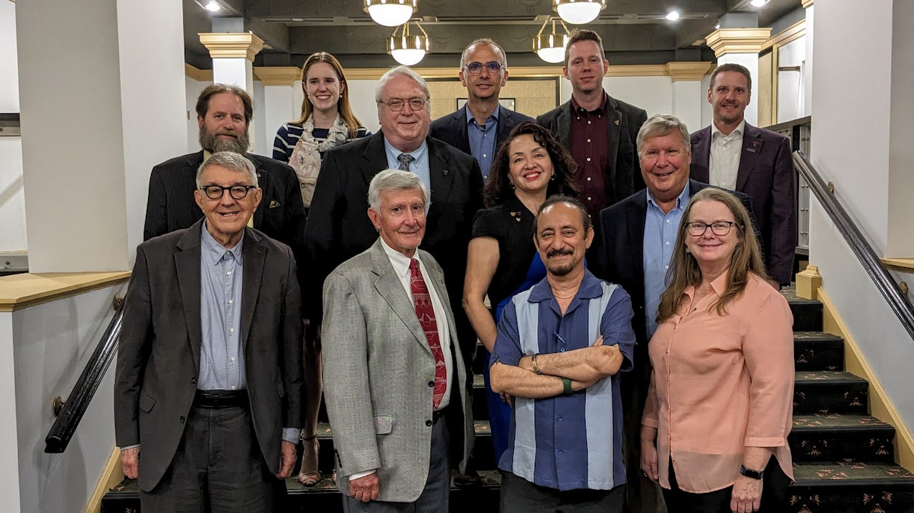
Photo: Past Presidents in attendance at the May 11, 2023 Past Presidents Lunch
Tom Batroney, PE
ASCE Pittsburgh Section Past President

