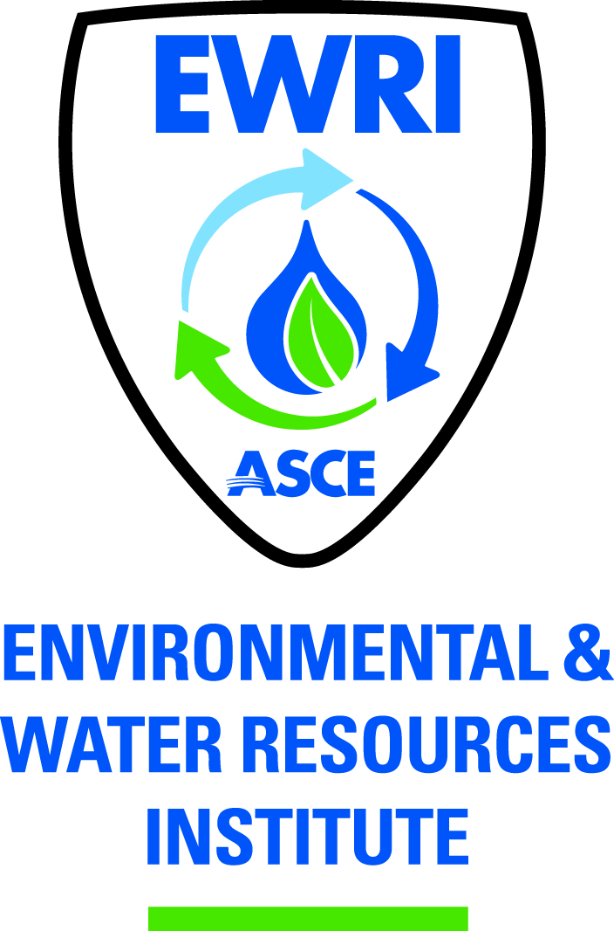

ASCE PITTSBURGH SECTION
EWRI MEETING MINUTES

Wednesday, September 25, 2013 3:30 PM
Tetra Tech, Inc.
661 Anderson Drive (Foster Plaza 7)
Pittsburgh, PA 15220
2nd Floor Reception Conference Room

Chair: Jonathan Shimko
Past Chair: Tom Batroney
Vice Chair: Vacant
Treasurer: Vacant
Secretary: Liwei Zhang

Meeting attendees: Sina Arjmand, Tom Batroney, Matt Mehalik, Kemal Niksic, Jonathan Shimko, Sam Shamsi, Brandi Eng-Rohrbach, Alex Lackner, Liwei Zhang

- Approval of June & July & August meeting minutes

Minutes

Liwei made a motion to approve the minutes; Jonathan seconded the motion with no objection. Motion passed. All meeting minutes were approved.

- Treasurer’s Report

Minutes

Treasurer’s report was not available, due to the absence of the treasurer. Current balance should be $5120—need to confirm with the treasurer.

- Vice Chair & Treasurer Position

Minutes

Both positions are still vacant, and a search committee will be formed to find good candidates for the Vice Chair position. Sam Shamsi might take the position of Vice Chair, depending on his future schedule.

- Dinner Events

- Water Treatment (Kemal)

  - PAWC upgrades
  - Hatch Mott pilot study
  - PWSA
  - Central Pa Nitrate Removal

Minutes

Kemal is still waiting for response from people at Erie.

- Wet Weather Overflow Disinfection (Greg Scott or others??)

- GIS Topic – Sam Shamsi

Minutes

Sam’s GIS project: Evaluation of 550,000 locations in Allengheny County that have potential for green infrastructure (e.g., raining garden).

Kemal: This project can be a good topic for a dinner event. It is good for EWRI to invite Sam to talk about his GIS project in Feb or March 2014.

- Annual Sustainability Conference
Water-Energy Nexus
January 23rd at Phipps Conservatory
Keynote Speaker: Councilman William Peduto

Minutes

Good to collaborate with Water Economy Network (WEN). WEN can be a partner to organize the conference.

Potential topics for the Councilman: should be related to Pittsburgh

Another keynote speaker who will talk about water-energy in national perspective: a speaker from NETL will be good.

The third keynote speaker can be from WEN.

Preliminary plan: 3 keynote speakers: Pittsburgh Councilman, a speaker from NETL, and a speaker from WEN. First speaker: 8:15 to 9:00 am (30 min presentation and 15 min Q & A); Second speaker: 9:00 to 9: 45 am; break: 9:45 to 10:00 am; Third speaker: 10:00 to 10:45 am.

  - Topics/Speakers –
    - Biologic Fuel Cells - Dr. Bruce Logan
    - Dr. Alexander Hakala from NETL—topic TBD
    - Heat Recovery - Philadelphia Water Department?
    - ACEEE - ?
    - Others…?

Minutes

Other speakers/topics:
1) Dr. Larry Wackatt from University of Minnisota
His research: Treatment of flow back water using biological treatment methods

2) Tom Joseph (from Epiphany): Solar distillation to treat fracking water

3) Good topic: smart module for real-time pump control. Speaker TBD

  - Sponsors/Vendors –
    - Vendor Participation
    - Traditional Sponsors (GAI, HMM, AECOM, etc…)

Minutes

Sponsors: Kemal will talk with potential sponsors and Jonathan will help Kemal. Matt will contact companies in his energy company list. Good to prepare a list of people and companies that we can solicit money from.

Total cost to organize this conference: $8,000

Sponsor solicitation goal: $5,000
Registration from attendees: $3,000

Student: $5 per person (tentative)

  - Additional Considerations

Minutes

Poster session—during the breaks
Can ask EWB (Engineer without boarder) to prepare a poster about water supply in Ecuador and utilization of solar energy in India

Afternoon agenda (focus on shale and power generation):

Kick-off: Dr. Larry Wackatt

Two speakers talking about power generation: one from NRG (technical aspect) and one from public sector (legislation aspect)

Matt: Online marketing: 30 sec video spot to advertise the conference. Cost: $1100; may be reduced to $900

Big concern: How to attract attendees???
Kemal: e-mail blast
Jonathan: reach people in different industries

Liwei will take lead to find a higher-profile speaker from NETL as the key note speaker; Liwei will also send Bruce Logan an e-mail to update him about the conference. Tom and Liwei will take the responsibility of inviting national-level speakers.

Geothermal work at Phipps Conservatory can be a good topic for a lunch talk.

- CMU Grad Student Chapter Update

Minutes

CMU Chapter hosted a kick-off meeting on September 11. Attendee number is about 20.

- Pitt Grad Student Chapter Update

Minutes

U Pitt Chapter had a presentation in the CEE orientation week. The chapter got 34 members so far. Board members (e.g., President, Vice President and Treasurer) have been filled in.

U Pitt Chapter happy hour: October 4th (EWRI and IAHR members).

U Pitt Chapter can help the EWRI Pittsburgh Chapter build the website.

Last Friday (Sep 20): U Pitt Chapter 1st General Body Meeting

Ongoing event: Organization of mini-classes to teach students using hydrologic software, GIS software, EPA code, etc.

- Other Items/New Business
  - ASCE Newsletter (September 2013)
  - Membership/Participation
    - Young Members Forum
    - UPJ
    - Other opportunities?
  - ASCE Section Website Updates

- Other Items/Next Meeting Location?

Minutes

Jonathan did not get $500 reimbursement from ASCE. Jonathan will call Bob Dengler at ASCE to request this reimbursement.

Next meeting time & location: October 22nd, Bar Louie in Station Square

