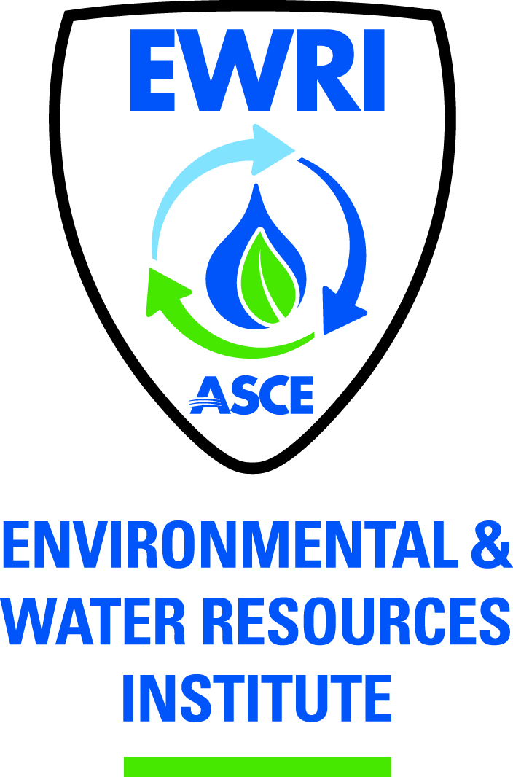

ASCE PITTSBURGH SECTION
EWRI MEETING SUMMARY

Tuesday, August 6, 2013 4:00 PM
HMM Office
Pittsburgh, PA
Chair: Jonathan Shimko
Past Chair: Tom Batroney
Vice Chair: Vacant
Treasurer: Vacant
Secretary: Liwei Zhang

Meeting attendees: Tom Batroney, Kemal Niksic, Karen Riley, Greg Scott, Jonathan Shimko, Liwei Zhang

1. VC and Treasurer positions
None of the positions have yet been officially filled. Tim is willing to serve as the Treasurer. Kemal will be in charge of a vice chair recruiting committee to find a new vice chair.

2. Sustainability conference
Keynote: 8:30 to 9:15 am. The keynote speaker has not been confirmed. Tentative plan: invite two keynote speakers, one can be a local politician and the other can be a technical people working on water and energy.
The candidate running for Pittsburgh Mayor (Bill Peduto) will be a good keynote speaker. Greg: will try to reach Bill Peduto. Back-up plan: people from ACEEEE.org; Secretary of DOE,

Potential topics for break-out session: energy saving in wastewater treatment; energy production using algae; micro-turbine for energy recovery from wastewater/stormwater; toolbox for GHG production from WWTPs; transfer of wastewater heat recovery technology from Philadelphia to Pittsburgh; water and energy in the perspective of household use; steam generation at Pittsburgh.

Microbial fuel cell: The speaker, Prof. Bruce Logan from Penn State, is confirmed.

Phipps has a geothermal energy supply system. Jonathan is going to ask people at Phipps about the potential for a speaker from Phipps to talk about this system.

Expected number of attendees: ~100

Tom: The conference should have at least three speakers. 5-6 speakers will be a good number. There should be a 10-min break between two presentations. The break time can be used for vendors to exhibit their products. Table spaces need to be reserved for vendors. A registration fee (TBD) will be collected from each vendor. [Karen: It is doable to let vendors sponsor breakfast.]

Kemal: will contact Jason Murray, who is in charge of heat recovery project in Philadelphia.

Jonathan: will talk with people in charge of micro-turbine project in Pittsburgh; will talk with people in WWTPs equipped with flow back water treatment systems (e.g., AquaTec Zero-liquid Discharge System).

Greg: Utilization of wastewater from dairy farm to produce bio-gas will be a good topic. It is of interest to organize a CEC tour after the conference.

Karen: Treatment of flow back water from fracking will be a good topic. It is of interest to find a speaker from Talisman (a natural gas drilling company) to talk about this. Specific topics include energy-efficient treatment of flow back water and re-use of flow back water [Greg: Siemens has done energy saving work in flow back water treatment]. We can also search for potential speakers from energy-related committees in DC. It is also good to have media coverage.

Liwei: It is good to have a poster session for students. Liwei needs to confirm that CMU is able to host the next meeting.

Need to report the progress in organizing the sustainability conference at the ASCE kick-off meeting, Sep 26th

Sustainability conference write-up refinement: Tom and Jonathan will work on that. The write-up will be sent to Jessica to add special graphical effects.

Date: Jan 21st or 23rd, 2014 (Tuesday or Thursday). Tim can contact Phipps to reserve venue.

