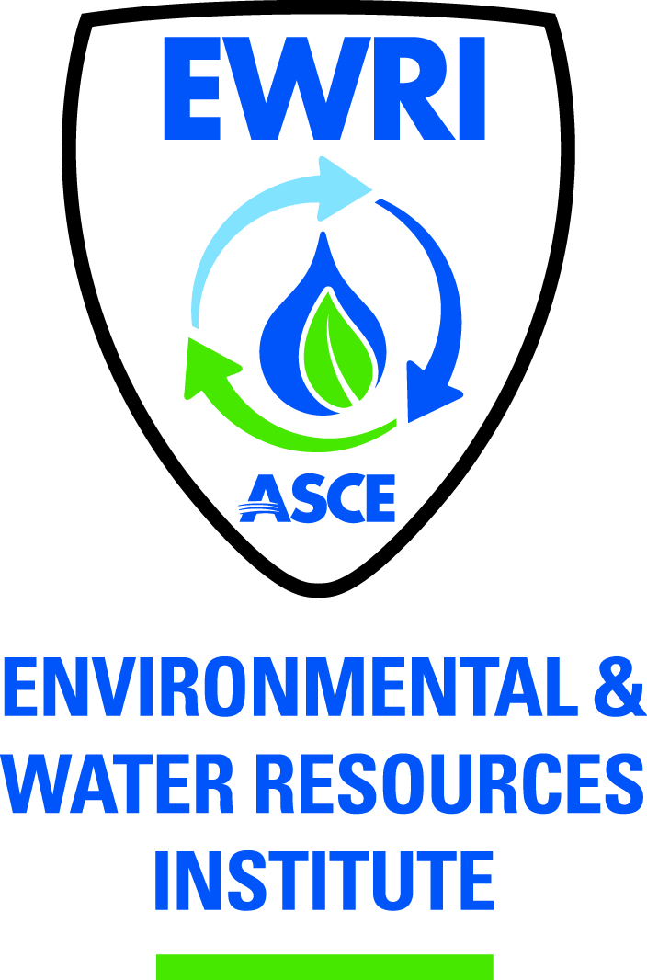

ASCE PITTSBURGH SECTION
EWRI MEETING AGENDA (Meeting Minutes)

Tuesday, June 18, 2012 at 3:30 PM
Offices of Gannett Fleming, Inc.
601 Holiday Drive
Pittsburgh, PA 15220

- Approval of April/May meeting minutes

Minutes:
Kyle made a motion to approve April meeting minutes. Tom’s seconded the motion with no dissent. Motion passed. April meeting minutes approved.

- Treasurer’s Report

- Vice President Nominations

Minutes:
Tom made a motion to make Josef vice chairman, Kyle seconded the motion with no dissent. Motion passed. Josef Argenio is new vice chairman.

Kyle made a motion to make Liwei new secretary, Josef seconded the motion with no dissent. Motion passed. Liwei is new secretary.

- ASCE Pittsburgh Annual Strategic Meeting – June 21

  - 1-year/5-year ASCE EWRI needs??

Minutes:
Time: This Thursday June 21. CMU Chapter needs to send an e-mail indicating the goal of the chapter and annual funding needed for the chapter.

Tom suggested targeting private and public sector.

  - Membership Committee – see handout

Minutes:
ASCE Pittsburgh has developed a plan to recruit more members in ASCE Pittsburgh.

Kemal: need people working on green infrastructure and stormwater

Jason and Kemal: adding more social events may be helpful to get more people involved.

Kyle: Go to colleges (e.g., job fairs, campus-wide event), Liwei will search for an appropriate event that EWRI can participate in at Carnegie Mellon.

Jason: need a strategy to enroll students at YMF to EWRI after they become professionals. Also workable to advertise EWRI events to YMF members and encourage them to join. Kemal and Tim to follow up with Jim Radion at Strategic Meeting

Tom: YMF holiday dinner do an EWRI Presentation

- Sustainability Conference Focus - “Smart Investment in our Region’s Valuable Infrastructure”

  - Reach out to Jeanne VanBriesen (Matt)

Minutes:

Jeanne is on vacation, but she will coordinate with people at water consortium after she gets back. Matt suggests waiting till Friday to get Jeanne’s reply.

Tim made a motion to reserve the Empress on October 11th for the sustainability conference contingent upon Jeanne’s availability. Josef seconded the motion with no dissent. Motion passed.

Josef proposes to have the July EWRI meeting at the Station Square, look at the Empress and organize a social event that comes together with the meeting. The meeting time will be moved to that Thursday (July 19).

  - Reach out to Colonel Graham (Kemal)
  - Gateway Clipper (Jerry) – Empress available October 11.
  - Asset Management
    - EPA CUPPS (Tom)
    - West Virginia Case Study (Greg)
    - System Owner (MTMA – Debbie)
    - Private Entity – PaAmerican Water??
    - Financial (Jason)

Minutes:
Organization of intersession workshops: Matt suggests having some speakers stop by as the leaders of the workshop groups. Need note taker for each group. Can request tables to be placed on the Empress for intersession workshops.

Debbie: John Elly? (System Owner) has the interest in speaking.
Kyle: discussion about capital improvement fee
Jason: try to find an accounting expert from a local bank
Josef: Warrner Lohlein? (army institute engineer and an adjunct professor at CMU) may be a potential speaker

- CMU Grad Student Chapter Update

Minutes:

Did not have any event last month

Will invite Tom to CMU on early September for new member recruitment

Liwei cannot attend the board meeting on Thursday; Tim will cover the progress of CMU chapter in his presentation.

- Dinner Events

June – CSO (Cancelled for June; reschedule for August??)

Dinner champion – Tim Brett
TMDL – PADEP/Case Study

Minutes:

Send letter to PaDEP voicing displeasure with reluctance to speak.
Jason: though the speaker may not be ready to talk at this time, it will be great to have a talk in the future, whenever the speaker feels comfortable.

??? – Stormwater

Dinner champion – Jason McBride
Possible topics:
Green Infrastructure in harsh environments
Mt. Lebanon storm rates - Tim to email Jason contacts

Minutes:

Kyle: possible to hold the event at Johnstown. Call professors to get students at universities involved

Matt: find someone to talk about green infrastructure issue under limited budget

Tom: Syracuse is making great effort in promotion of green infrastructure construction.

- 2012 EWRI Congress Report – Josef (see attached summary)

Minutes:

Josef talked with TMDL committee and sent the flyer to them.

- EWRI Congress application

Minutes:

Josef submitted the application to the EWRI council (competitors are Baltimore and South Florida)

- Other Items/Next Meeting Location?

Minutes:

Tabby got married. Tom made a motion to send her $XX gift card. Kyle seconded the motion with no dissent. Motion passed.

Meeting location and time: VIP Red Star at Station Square Thursday July 26 3:30 PM, need to publicize meeting on ASCE Webpage.

